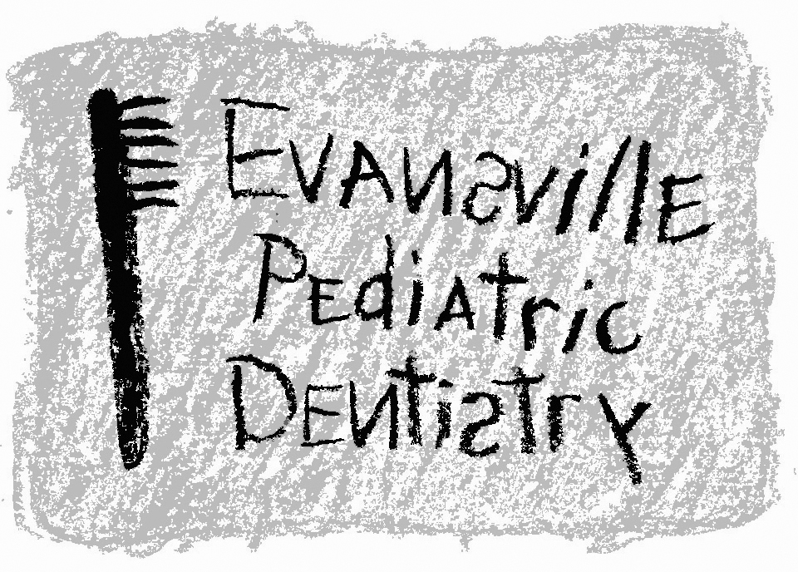
Jeffrey A. Hiester, D.D.S.
EAST WEST
7200 E. Virginia Street 2345 W. Franklin Street #101
Evansville, IN 47715 Evansville, IN 47712
(812) 479-8609 (812) 401-6095

Oral Sedation Pre-Appointment Instructions

- Your child should not eat or drink anything after midnight the day of the appointment

- If your child develops a cold, flu, or other illness the week prior to the appointment, please be sure to call the office, as the appointment may need to be rescheduled.

- If you find it necessary to cancel or change your child’s appointment, we ask that you contact the office at least 48 hours prior to the appointment date and time. Sedation appointments are reserved for your child only. If an appointment is cancelled or failed without notice, office policy states that there may be a fee charged and a future sedation appointment will not be scheduled.

- To make the child comfortable at the appointment, you are welcome to bring the child’s favorite toy, book, blanket, etc.

- We might ask that parents bring their child back to the dental chair and help place their child in the pediatric “wrap.” A papoose board helps to minimize the extent of uncontrollable bodily movements. We then want parents to wait in the waiting room so that we may give your child our full, undivided attention and complete treatment as quickly as possible.

- Keep in mind that not all conscious sedations will provide the level of sedation needed to complete any or all of the proposed dental treatment. If at any point in the sedation I believe that our treatment is too much for your child to handle or that I cannot provide dental treatment in a safe manner, I will stop the sedation and we will discuss alternative treatment options.

- I will only prescribe the amount of sedative that is appropriate for your child based on his weight. I will not give more sedative to a child based strictly on behavior or failed prior sedations. I plan to treat your child as if it were my own. There are certain risks associated with any procedure, specifically oral sedations, and I plan to minimize those risks as much as possible.

Thank you for your understanding, cooperation, and trust you place in me to treat your child. If you ever have any questions concerning the proposed dental treatment, please call me at (812) 479-8609.

Thanks again,

Jeffrey A. Hiester, D.D.S.

